Lab 11 : Bloblang Troubleshooting & Console Navigation

Table of Contents
Table of Contents 2
Introduction 3
Learning Objectives 3
Prerequisites 3
Part 1 — The Danger of Bad Data 4
Part 2 — Implement Error Catching in YAML 5
Architecture Breakdown 6
Part 3 — Execute and Break the Pipeline 7
Step 1 — Run the Pipeline 7
Step 2 — Inject "Poison" Data 7
Part 4 — Troubleshooting in the Cloud Console 8
The Fix 10
Knowledge Check 11
Troubleshooting 11
Symptom: The DLQ topic is empty. 11
Symptom: Docker logs show Failed to connect to kafka. 11
Next Steps 12
Conclusion 12

Introduction
In a perfect world, all streaming data perfectly matches your expected schema. In reality, producers change schemas, fields go missing, and data types shift (e.g., a number suddenly arrives as a string).
When a Bloblang processor encounters an error (like trying to do math on a string, or accessing a field that doesn't exist), it needs a way to fail gracefully. If not handled, bad data can be dropped or stall the pipeline.
In this lab, you will write a pipeline that intentionally performs risky mathematical mappings. You will use Redpanda Connect's catch processor to route failures, and then use the Redpanda Cloud Console to visually inspect the errors and troubleshoot the bad data.

Learning Objectives
Upon completing this lab, you will be able to:
- Identify common mapping errors caused by malformed data.
- Use the catch processor block in YAML to handle Bloblang exceptions.
- Add diagnostic metadata to failed payloads.
- Navigate the Redpanda Cloud UI to isolate and debug pipeline failures.

Prerequisites
- Completion of Lab 16.
- rpk installed and authenticated.
- Docker installed and running.

Part 1 — The Danger of Bad Data
First, let's create two new topics: one for raw data, and a Dead Letter Queue (DLQ) for our mapping failures.
rpk topic create financial-raw

rpk topic create financial-dlq

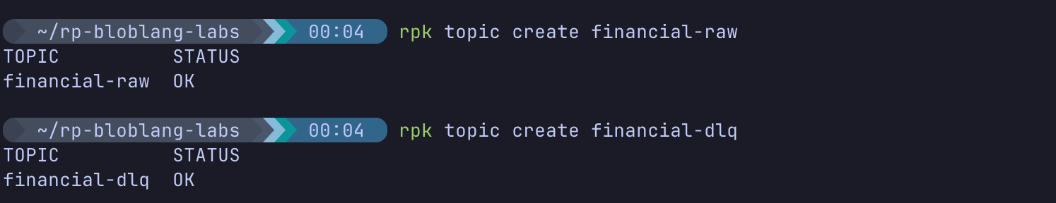
Our pipeline will attempt to calculate a tax value: this.amount * 0.20. What happens if the amount field is completely missing? The mapping will fail.

Part 2 — Implement Error Catching in YAML
Create a new pipeline configuration file:
cd ~/rp-bloblang-labs

error_pipeline.yaml

Paste the following configuration. Remember to update your Cloud credentials!
input:
kafka:
addresses: [ "YOUR_BOOTSTRAP_SERVER_URL:9092" ]
topics: [ "financial-raw" ]
consumer_group: "bloblang-error-group"
tls: { enabled: true }
sasl:
mechanism: SCRAM-SHA-256
user: "your_username"
password: "your_password"
pipeline:
processors:
# 1. The TRY block attempts to run our risky mapping
- try:
- bloblang: |
root = this
# RISKY: Will fail if 'amount' is missing or isn't a number
root.tax_calculated = this.amount * 0.20
root.status = "SUCCESS"
# 2. The CATCH block ONLY executes if the Try block throws an error
- catch:
- bloblang: |
root = this
root.status = "FAILED"
root.mapping_error_reason = error()
output:
# We use a switch to route the data based on its status!
switch:
cases:
- check: this.status == "FAILED"
output:
kafka:
addresses: [ "YOUR_BOOTSTRAP_SERVER_URL:9092" ]
topic: "financial-dlq"
tls: { enabled: true }
sasl:
mechanism: SCRAM-SHA-256
user: "your_username"
password: "your_password"
# We drop successful messages in this lab to focus purely on the errors
- output:
drop: {}

(Save and exit).

Architecture Breakdown
- try / catch processors: Redpanda Connect executes processors sequentially. If the Bloblang script inside the try block crashes, the message is immediately passed to the catch block.
- error() function: A special Bloblang function that captures the exact system error message that caused the failure.
- switch output: Routes messages to different destinations based on their contents.

Part 3 — Execute and Break the Pipeline

Step 1 — Run the Pipeline
Run the pipeline via Docker:
docker run --rm -it \
-v $(pwd):/data \
redpandadata/connect:latest \
-c /data/error_pipeline.yaml

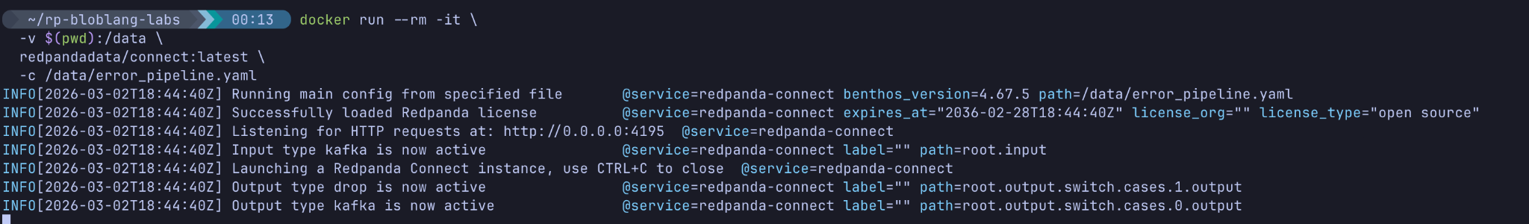

Step 2 — Inject "Poison" Data
Open a second terminal window and produce data designed to break our math logic.
rpk topic produce financial-raw
Send these three payloads (press Enter after each):
{"transaction_id": 1, "amount": 100}
{"transaction_id": 2}
{"transaction_id": 3, "amount": "Unknown"}

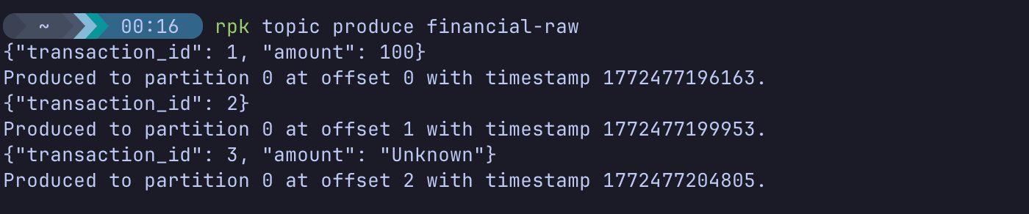
(Press Ctrl+D to exit).
- Payload 1 is valid. It will succeed and be dropped by our switch output.
- Payload 2 is missing the amount field entirely.
- Payload 3 has an amount field, but it is a string, not an integer.

Part 4 — Troubleshooting in the Cloud Console
Instead of using rpk to read the DLQ, let's use the UI like a real platform operator debugging an active pipeline issue.
- Open your browser and log into the Redpanda Cloud UI.
- Select your Serverless cluster.
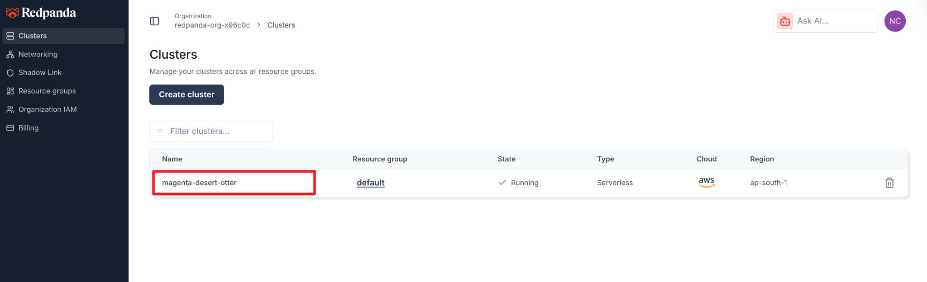
- On the left sidebar, click Topics.
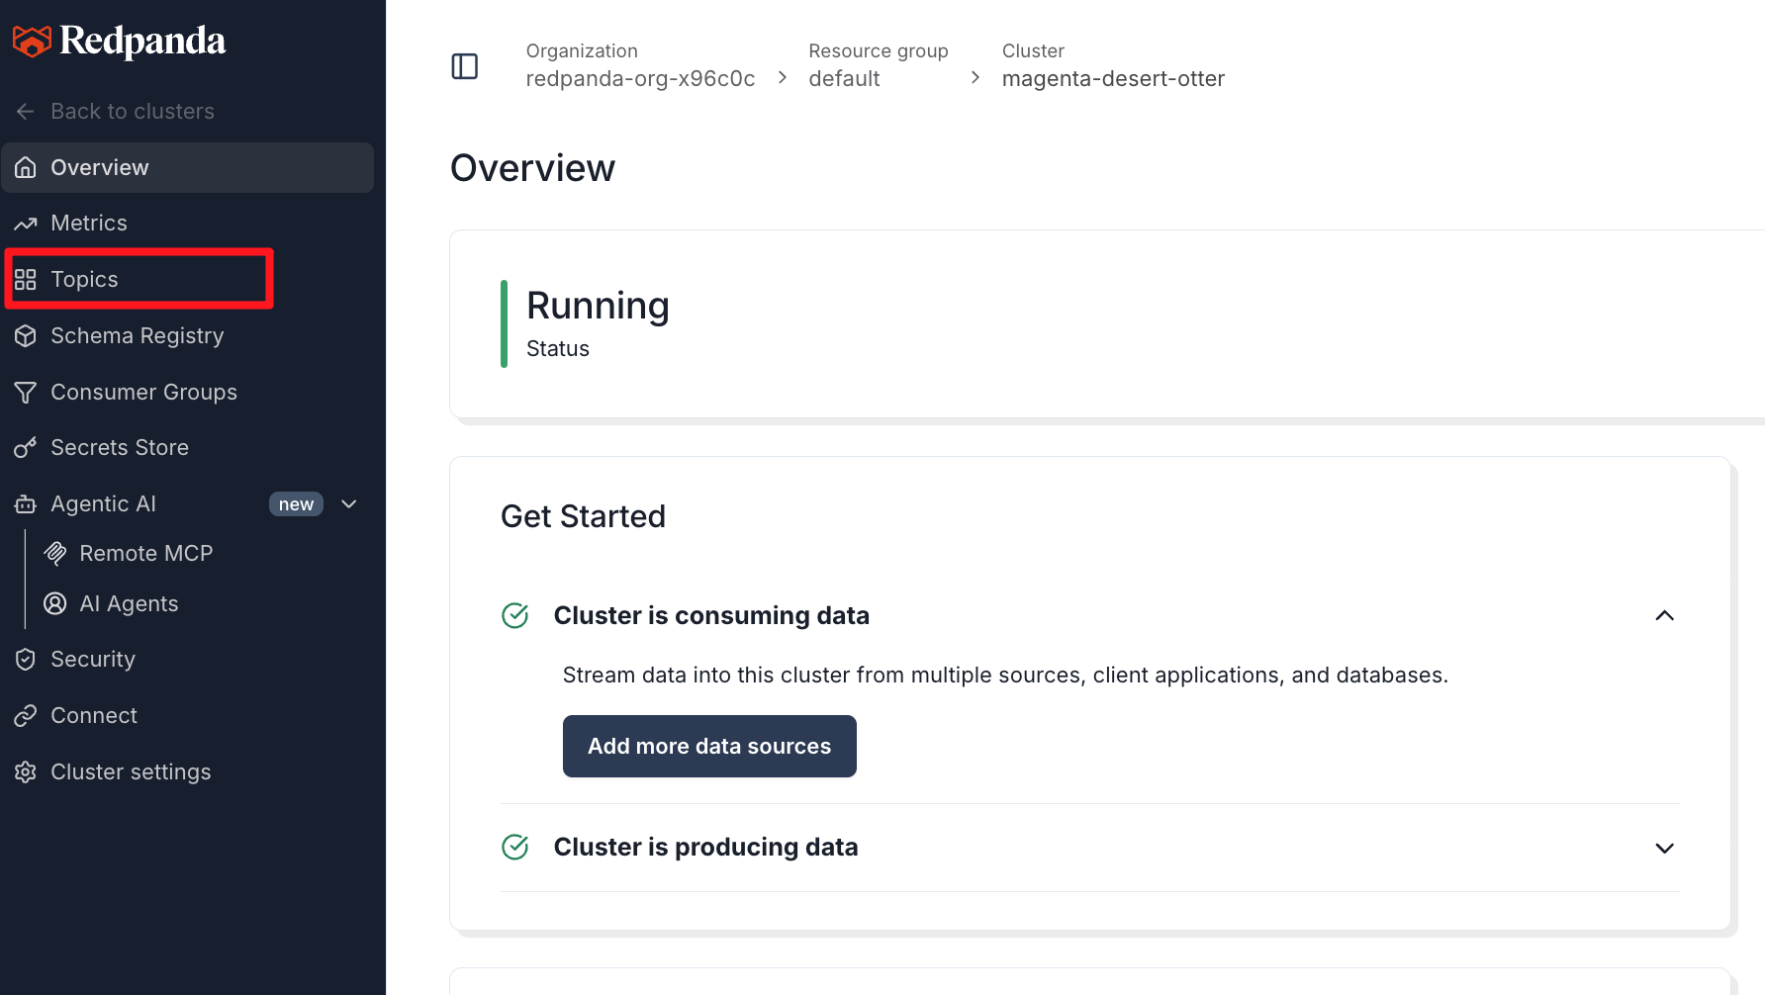
- Click on the financial-dlq topic, then select the Messages tab.
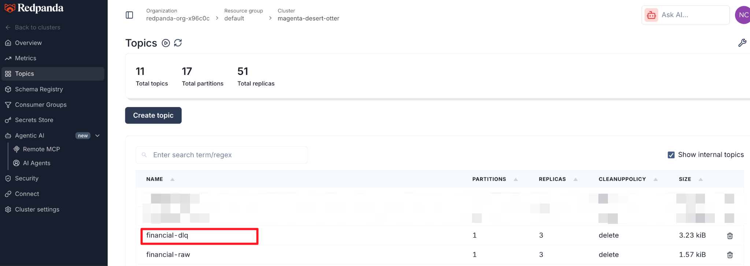
Analyze the Results: You should see exactly two messages in the topic. Expand the JSON payloads to view them.
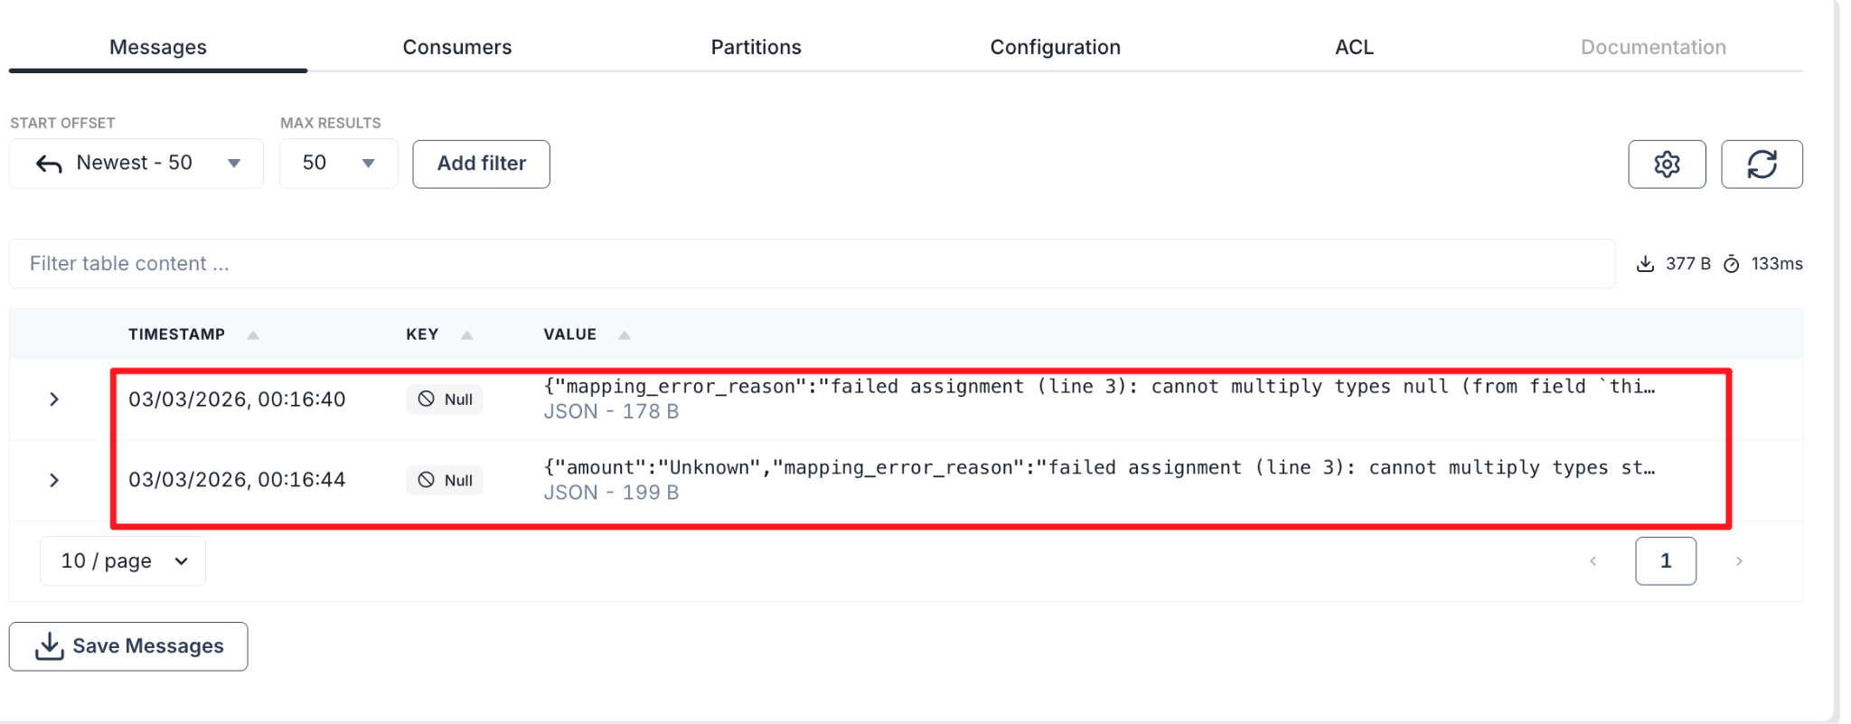
Message 1 (Transaction 2):
{
"transaction_id": 2,
"status": "FAILED",
"mapping_error_reason": "cannot multiply types null and float64"
}
- Diagnosis: The amount field was missing, so Bloblang evaluated it as null.
Message 2 (Transaction 3):
{
"transaction_id": 3,
"amount": "Unknown",
"status": "FAILED",
"mapping_error_reason": "cannot multiply types string and float64"
}
- Diagnosis: The amount field was present, but it was a string.

Knowledge Check
- What does the error() function do in Bloblang?
  - Answer: It captures and returns the system error string that caused the preceding mapping to fail, allowing you to attach it directly to the payload for debugging.
- Why did we use a try block instead of just a standard bloblang processor?
  - Answer: If a standard processor fails, the message is either dropped or flagged and sent to the output unmodified (depending on configurations). By wrapping it in a try/catch, we take explicit control of the failure routing and enrichment.
- How does the switch output work?
  - Answer: It acts like an if/else statement for routing. It evaluates conditions (like check: this.status == "FAILED") top-to-bottom and sends the message to the first output that matches.

Troubleshooting

Symptom: The DLQ topic is empty.
Solution: Ensure you produced the bad data payloads exactly as shown (with missing or string amount fields). Ensure your switch block in the YAML has the correct topic name (financial-dlq) and valid cloud credentials.

Symptom: Docker logs show Failed to connect to kafka.
Solution: Ensure your BOOTSTRAP_SERVER_URL and SASL credentials are correct in both the input block and the DLQ output block of the YAML.

Next Steps
Clean up your environment by deleting the test topics:
rpk topic delete financial-raw financial-dlq

Conclusion
In this lab, you leveled up your pipeline engineering skills. You learned that bad data is inevitable, and building brittle pipelines is dangerous. By utilizing the try/catch processors, Bloblang's error() function, and the Redpanda Cloud Console, you built a self-documenting pipeline that automatically isolates bad data and explains exactly why it failed.

